## Theory&Concept

Objective:-Toimplement theconcept ofSub Queries.

**Sub Queries:- A Sub Queries** is a form of an SQL statement that appears inside another SQL statement. It also termed as nested Questionry. The statement containing a Sub Queries called aparent statement. The rows returned bu the Sub Queries are use bythe following statement.

Itcanbeusedbythefollowingcommands:

1. Toinsertrecordsinthetargettable.
2. Tocreatetablesandinsertrecordsinthistable.
3. To updaterecordsinthe targettable.
4. Tocreateview.
5. To provide values for the condition in the WHERE , HAVING IN , SELECT,UPDATE, and DELETE statements.

Example: Creating client master table from oldclient_master, table Createtableclient_masterASSELECT*FROMoldclient_master; **Using the Union, Intersect and Minus Clause:**

UnionClause:

The user can put together multiple Queries and combine their output using the union clause . The union clause merges the output of two ormoreQueries into a single set of rows and column. The final output of union clause will be

Output:=RecordsonlyinQuestionryone + records onlyin Questionrytwo +Asingle set ofrecords with is common in the both Queries.

Syntax:SELECTcolumnname,columname FROMtablename1 UNION SELECTcolumnname,columnnameFromtablename2;

**IntersectClause:**TheusecanputtogethermultipleQueriesandtheiroutputusingtheinterest clause. The final output of the interest clause will be :

Output=Asingle setofrecordswhicharecommoninbothQueries Syntax:SELECTcolumnname, columnname

FROMtablename1 INTERSECT

SELECTcolumnname,columnname FROM tablename 2;

MINUS CLAUSE:- The user can put together multiple Queries and combine their output =recordsonly in Questionry one

Syntax:SELECTcolumnname,columnname FROM tablename MINUS

SELECTcolumnname,columnname FROM tablename ;

## ExperimentNo.8

**Objective:**AnswerthefollowingQueries:

QUERIES:

1. Find the product_no and description of non-moving products.

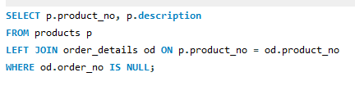

1. Find the customer name ,address ,city and pincode for the client who has placed or derno “019001”

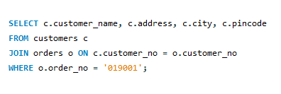

1. Find the client names who have placed order be fore them on thfmay96.

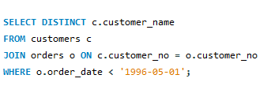

1. Findoutifproduct“1.44Drive”isorderedbyonlyclientandprinttheclient_nonameto whom it was sold.

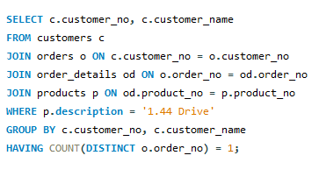

1. Find the names of client who have placed ordersworthRs.10000ormore.

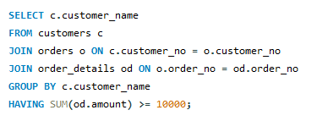

1. Select the orders placed by ‘RahulDesai”

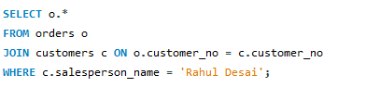

1. Select the names of persons who are in Mr. Pradeep’s department and who have also worked on an inventory control system.

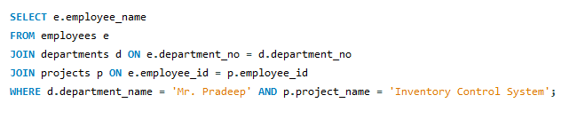

1. Select all the clients and the sales man in the city of Bombay.

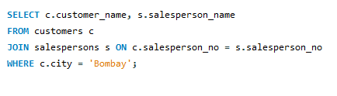

1. Select sales man name in“Bombay” who has atleast one client locate dat “Bombay”

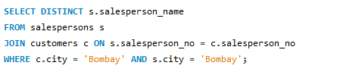

1. Select the product_no, description, qty_on-hand,cost_price of non_moving items in the product_master table.

